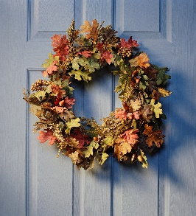
Newsletter June 2023
Now we welcome the beautiful summer, and the board hopes that everyone will have a wonderful period of relaxation and many fun activities!
Barbecues
The grills on the farm are there so that Kallkällan’ s members will have the opportunity to grill, and we hope that everyone takes the opportunity to use them. Just remember to clean up after yourself so that no trash is left behind. Food scraps attract rats and birds. The ashes are cleared and placed in the buckets. It is not allowed to grill on the balconies, and this also applies to electric grills.
Flower boxes on the balconies
It is very nice to have plants on the balconies. If you want a flower box, hang it on the inside.
Parking for bicycles and electric scooters
It is positive that many people use bicycles, which is good for both health and the environment. Remember to park the bikes at bike racks or in bike storage. Electric scooters and "Styr&Ställ-bikes" must be parked at bike racks and not in other places.
Increase in annual fees and rents
Increased costs for interest, energy, municipal rates (water, sewage, rubbish, property rights), property management, cleaning and management contracts and maintenance means that annual fees and rents increases as from July 1st. Annual fees with 8%, garage spaces with 10% and outdoor parking spaces with 50 SEK/month.
HSB's solar park
On August 1st, Kallkällan will be connected to HSB's solar park in Sörmland and then the association will receive an electricity trade price of 40 öre/kWh for the common electricity consumption.
Maintenance
June 2023: Renovation of the facades of the heated garage. 2024 (Preliminary): The load-bearing structure in the garage on Kallebäcksvägen is renovated.
The order in the laundry rooms
The board must once again remind about the order in laundry rooms and drying rooms. Everyone must clean up after themselves, and this applies to both machines and floors.
The planter urns
The urns are planted with summer flowers before midsummer and it should hopefully be ready when this newsletter is published.
Association meeting
This year's general meeting is planned to take place on November 21st. Then, as usual, we review the operations and finances for the past year. During September, you will have the opportunity to submit motions to the general meeting. The meeting is an important event for Kallkällan members, so book the time now. Notice and annual report will be sent 2-6 weeks before the meeting.
The recreation room and the guest apartment
Bags with first aid have been set up in the recreation room and the guest apartment.
Association office closed: Summer closed weeks 28-32. Opens again 21/8 at 18-20.
The board of HSB Brf Kallkällan wishes all members a nice summer!

